#### 列出具有相同IP的设备

select * from player where id in (

select playerId from player_attribute b where b.`name` = 'player_local_ip' and b.`value` in (

select ip from (

select a.`value` ip, count(a.`value`) ip_count from player_attribute a where a.`name` = 'player_local_ip' GROUP BY a.`value`

) as ips where ips.ip_count>1

)

);

注意：如果上述Sql返回0条记录，则表示没有相同ip的终端。

#### 列出没有升级到特定软件版本设备

针对player和receiver的查询语句如下面所示，但要根据具体的情况选择相关的SQL语句，并修改相关的“终端设备类型编号”和“终端版本号”等。其中，医护对讲的的设备类型取值如下：

{ "code": "WM_1", "name": "医护主机" },

{ "code": "WM_2", "name": "医护副机" },

{ "code": "WM_3", "name": "护士站白板" },

{ "code": "WM_4", "name": "走廊双面屏" },

{ "code": "WM_5", "name": "病区门口机" },

{ "code": "WM_6", "name": "家属探视机" },

{ "code": "WM_7", "name": "门口机" },

{ "code": "WM_8", "name": "床头机" },

{ "code": "WM_10", "name": "床旁机" },

{ "code": "WM_11", "name": "医护手环" },

{ "code": "WM_12", "name": "移动探视车" }

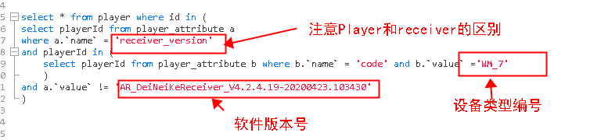

* 针对特定设备类型的player：

select * from player where id in (select playerId from player_attribute a where a.`name` = 'version' and playerId in (select playerId from player_attribute b where b.`name` = 'code' and b.`value` ='WM_7') and a.`value` != 'Player-V6.0.5.19-20200622.102037')

* 针对所有的player：

select * from player where id in (select playerId from player_attribute a where a.`name` = 'version' and a.`value` != 'Player-V6.0.5.19-20200622.102037')

* 针对特定设备类型的receiver：

select * from player where id in (select playerId from player_attribute a where a.`name` = 'receiver_version' and playerId in (select playerId from player_attribute b where b.`name` = 'code' and b.`value` ='WM_7') and a.`value` != 'AR_DeiNeiKeReceiver_V4.2.4.19-20200423.103430')

* 针对所有的receiver：

select * from player where id in (select playerId from player_attribute a where a.`name` = 'receiver_version' and a.`value` != 'AR_DeiNeiKeReceiver_V4.2.4.19-20200423.103430')